Business Week Teaches Community Building
White Pass High School students learn about business and expand their horizons
by Alyssa Westall
Center for the Improvement of Student Learning
alyssa.westall@k12.wa.us
“If this is what a college class is like, then college isn’t as hard as I thought,” said a student.

Student teams developed multi-million dollar companies and competed in a variety of categories. The winning team sold a product that translated a baby’s cry – “I’m hungry,” “I’m tired,” “My diaper is wet.”
See more pictures of Business Week at White Pass High School.

In the rural community of Randle, Wash., White Pass School District hosts Business Week, an event that gives juniors and seniors hands-on experience with college-level economics and real-life business scenarios. The event takes place in March, during the same week that sophomores are taking the Washington State Assessment of Student Learning (WASL).
In the White Pass School District, 50 percent of its students qualify for free-and-reduced lunch.
“They think owning a business is so far beyond them,” said Hazelanna McMahan, a local business owner and community leader. “Kids need to know they have choices. Business Week opens our kids’ eyes to a world they may not have known.”
One student, a junior, agreed. “I learned that a poor person can own a successful business.”
How it works
Washington Business Week is a week-long opportunity for high school students to learn about teamwork, leadership, and setting real-life goals. Student's run a simulated business, face real-life challenges and prepare for their futures.
At White Pass, students were split into teams with a teacher and a community adviser. They each developed a multi-million-dollar company, learning important concepts about international trade, supply and demand, environmental issues, ethics, leadership, marketing and the global economy. The mock companies competed for the top spot in a variety of categories, such as sales, team spirit and stocks.
Each team selected a CEO, plant manager, marketing manager, production manager and other key roles. Throughout the week, they made decisions together that determined the success of their company.
In addition, local community leaders told students about their own pathways to success.
Chris Loftis, a Business Week facilitator, led student assemblies and talked about students’ transition into adulthood. “If you have a dream, there is a path to get there,” said Chris. “You are the one person who can help or hurt your future.”
How students benefit
Students practice important life skills:
- Creativity – develop a marketing plan, commercial, sales pitch and company logo.
- Public speaking – give presentations to community members posing as stockholders.
- Networking and sales – display their products in a trade show.
- Professionalism – dress appropriately, make eye contact, introduce themselves.
At the end of the week, students receive a certificate that they can include in their portfolio and résumé.
“Business Week gives students a connection with life skills. They see the importance of what they are learning in reading and math.” – Karen Larsen, White Pass High School principal.
“Students gain confidence. Kids who don’t think they can do anything realize they can.” - paraeducator Judy Roberts.
“Kids learn they can figure things out for themselves. You should leave most of the work to the kids.” - John Westall, math and science teacher.
“We have a lot to show kids that we don’t always show in the classroom.” - Darci Rashoff, business teacher.

The importance of team work
Students were teamed up with kids that they didn’t normally socialize with. What started out as total chaos on Monday was a cohesive unit by the end of the week.
“My group had different personalities, and they learned how to work through differences,” said community advisor Tim Johnson. “They learned to take criticism and give input. They experienced failure and learned that they can fail and everything will be okay. Nobody’s perfect. Failure will make a team stronger.”
“Business Week brings out leaders in kids whose talents aren’t always noticed,” said Karen Larsen, the high school’s principal. “Kids are normally recognized for doing well academically and in athletics. This is an opportunity for other talents to shine.”
Karen added that kids get along better after Business Week and that there are fewer disciplinary problems. They learn to value each other more.
A strong feeling of community
Each team was sponsored by a local business. Community members filled the school gymnasium during the trade show, asking students about their businesses and products.
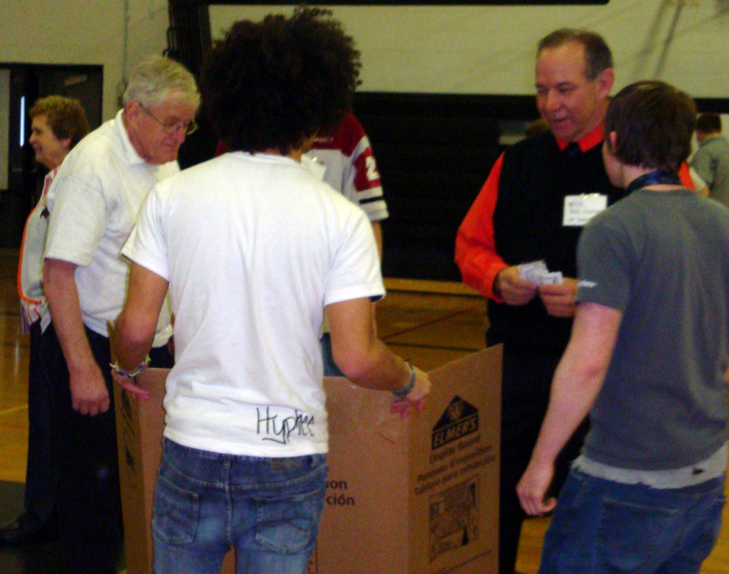
Superintendent Rick Linehan, school staff, school board directors and community members act as stock holders at the trade show.
“Your community cares about you. During these hard economic times, they have donated generously to this event. They believe in you and know your education is important,” the district’s superintendent, Rick Linehan, told students.
“Every person is an expert about something in their life and can share it. There are some amazing individuals in every community,” said Hazelanna McMahan, who was instrumental in initiating the program at White Pass. “We learn more about business and the younger generation, what makes them tick. It helps us to market our products to them.”
Hampton Lumber Mill, the area’s largest employer, sent two supervisors to serve as community advisers. Supervisor Tim Johnson learned that his workers “need more stimulus – they can multitask!”
“Students are different now,” said business teacher Darci Rashoff. “They can listen even though they appear to be doing several other things.”
Local employers tell students about job expectations. “We expect you to be at work, on time. We have a very strict attendance policy,” a community adviser told one tardy student.
Getting the program started
Washington Business Week also offers summer programs.
Read Washington Business Week’s Annual Report.

- Start planning about a year in advance.
- Get buy-in from staff, administration and the community.
- Consider partnering with neighboring districts and holding the event at a local community college. For example, Chehalis, Centralia and Winlock School Districts held the event at Centralia Community College. Students enjoyed working with their peers from other districts and benefited from the experience of going to a college campus.
- Find a week that does not have any other events, such as sports, that would pull students away.
- Contact Washington Business Week. They will walk you through the process.
- Consider experiencing Business Week at another district as a volunteer so you can bring that experience back.
- Start fundraising. The program costs approximately $80-$125 per student.
- Designate a staff member to be in charge. At White Pass, this was previously paraeducator Judy Roberts. This year she handed the reins over to business teacher Darci Rashoff. They estimated that it takes about 100 hours of staff time to prepare for Business Week, and it is their full focus during the five-day event.
- Find good community organizers and volunteers. Hazelanna McMahan volunteered 20-30 hours to do fundraising and recruit community volunteers prior to the event.
- Find supplies for students with which to make their products. Random things from around the house work best – it sparks their imagination.
- Divide kids into groups with peers that they don’t normally socialize with, but don’t mix kids from different grade levels.
Advice from principal Karen Larsen
“Do it without hesitation. It is great for the kids and community members,” said principal Karen Larsen. She cautioned that it is a lot of work. “Start with one class.”

